

HACETTEPE UNIVERSITY
BBM 473 FOURTH PHASE REPORT

GROUP MEMBERS

UMUT ÖZTÜRK
21328394

TALAT FARIMAZ
21127204

SUBJECT
BLOG SITE

DUE DATE
25.05.17

INTRODUCTION

We are at the last stage of the project. In this section we will find details of the project and reminiscent of the previous phases. Since it is the last phase, general information is deemed appropriate. First of all, we have to talk about the contents of the progeny. Our project is aimed at designing and implementing a web site with software content. Two types of users are defined within the site. These are the most authoritative and most important persons whom we define as admin and at the same time as the author. The other user type is defined by user name. The user's authority is restricted according to the admin. The authority of the admin in general can be listed as follows:
1. To create the articles on the site.
2. To update on the prints.
3. Blocking a user and view user information.
4. To edit comments made for blog posts.
5. To change or update the general structure of the site (blog title, etc.).
6. To create announcement.
Users in general have the following authority:
1. Users can comment on blog posts.
2. S/he can like blog posts.
3. Users can appreciate comments in blog posts.
4. The user has access to all typographical references. The most common expressions are the authority of site users.

After this information, we will briefly mention the phases of the progeny. In the first phase, the design phase, which is actually one of the most important parts for the project, was realized. The reason why it is so important is that the design is the most basic structure and the other phases are built on this basis. If there is a problem in the design, it is expected to be a problem in the other phases too. For this reason, a lot of time has been spent for the first phase and a nice design has emerged. The goodness of our design is clearly seen in the next phases. The goodness of the design is directly related to the relationships between the tables to be created. Already the most important reason for the emergence of the database is to manage the data in the most functional way. This management also depends on the most functional form of relations between the tables. In short, the data sheets to be integrated into the site in the first phase were tried to be created in the best way. Relations between the tables were also built with much thought.

In the next phase, coding was entered. The tables created in the first phase were created in the database with SQL. Procedures for adding, deleting, and updating the tables created in the Oracle database were described. These control procedures were then run and the functions mentioned on the database were performed. It is thought that this step has been accomplished successfully and easily. Because the design that was created in the previous phase is successful, it makes it easier.

In the third phase, a mini-application similar to the one in which the database was created was developed. In a similar manner, the username and password were used to connect to the database via the application. After entering the application, the previously created tables and records were displayed in the user interface. Addition, deletion and update operations were also performed. At the last stage, the most important part of the project was realized. We ended up here with the summary section to make more relevant information more detailed.

THE LAST PHASE IMPLEMENTATION
The desired requirement in the last phase can be called the final state of the progeny. In other words, a web application under the heading of the blog site is required. A blog site has been developed through the tabs created in the previous phases and in a real man page through a user interface.

First, the interface design was explored for HTML, CSS, and bootstrap related expressions. After getting general information about these languages, the design stage of the site was passed. This part has not worked so hard because I had some experience before. Then the PHP language was learned to make the site dynamic (data entry, data representation, etc.). Due to the lack of experience in this language, much research has been done and a lot of time has been spent at this stage. Oracle SQL (PL SQL) was used as the SQL language. From the very beginning, the Oracle database was already in operation. That's why research related to oracle SQL has been done. There are generally resources for MySQL connections on the Internet. For this reason, too much resources have not been found for oracle and there have been problems in this regard. But ultimately the desired information has been obtained.
The PHP language was used to design the tables in the system. In order to be able to connect to the database, the code that links to oracle SQL was searched. These codes were embedded in PHP files and data was fetched dynamically by connecting to the database. Accepted data are shown on the site in accordance with the requirements of the homework. Because there are multiple functions on the site, there are SQL queries written for different purposes in the generated PHP files. For this reason, great importance has been attached to database synchronization with PHP files.

As stated, the blog site has to have a dynamic structure. For this, it is also necessary to navigate between pages. When you look at the PHP code, you will see that the navigation between pages has been done. Again, the necessary SQL queries have been written. In short, the most important phase of this phase is synchronizing PHP files and linking to the database to bring up logical and necessary SQL queries. Then it is to use the query results in a functional way. Another important issue is design. It is mentioned that the design uses HTML, CSS and bootstrap. Features such as the appearance of the pages, buttons, in-site pictures, etc. have been realized thanks to these languages. In addition, bootstrap has been used in terms of welcome.

Another important point for the project was the environment in which the generated codes were run. XAMMP, WAMP instead of servers such as the department server is requested to work. For this reason, no external server is needed.

It is also necessary to mention the tools used in the development phase. A simple editor was enough for the languages mentioned. After writing on Notepad, it is transferred to the partition server. Then the url address is entered and checked. In short, a single tool has been sufficient to make improvements.

ENTRY TO SITE AND USAGE
It has been stated that site users are divided into two types in the first place. It is named admin, which is the site administrator, and users who are registered on the system. Since the two users have different authorities, they are expected to perform different functions at different interfaces. For this reason, two different interfaces are designed for both users. First, a simple input screen is designed as shown in the Figure 1. The e-mail address is required as the username on the login screen. The password is the password stored in the client's database. After this information is entered, database connection is checked to see if the user is registered in the system. If not registered, error message is given. The most important issue here is determining the user type. Different interfaces are opened according to user type. The administrator of the system is registered in the database with the mail address "ahmet@gmail.com". If this e-mail address is entered with the correct password, the admin page opens. If the entered e-mail address is different (it must be registered in the data directory) and the password is valid, the user page is redirected.

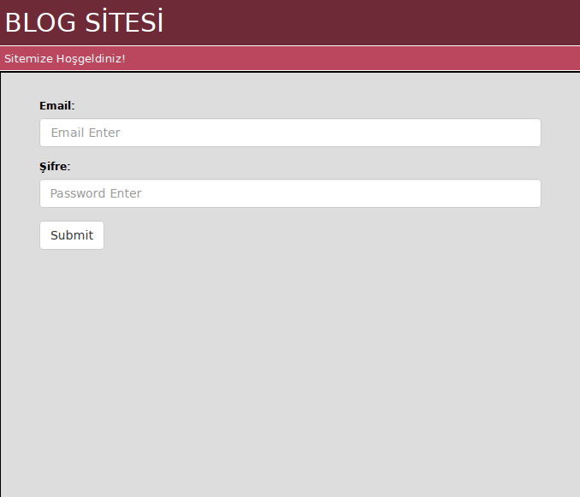
Figure 1. Login Page

As shown in the Figure 2, the admin page is accessed. Thanks to the buttons on this page admin authorities have been realized. The most basic functions such as making changes on the site, seeing the users, adding the blog post, viewing the site statistics, etc. are done via the buttons on the page. Even finer details and simpler operations are achieved without problems.

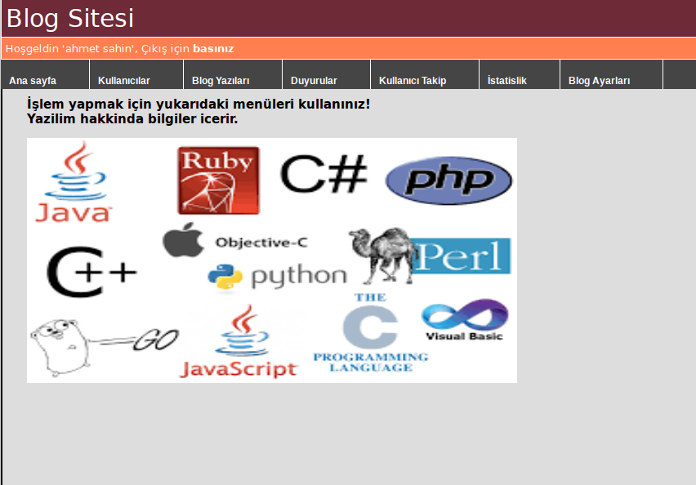
Figure 2. Admin Page

The Figure 3. also shows the user interface. Basic functions such as seeing blog posts, following announcements, seeing other users etc. are provided via the buttons on the page. It is provided that users can also use other authorities. Other authorities can be used by directing them with the buttons on the page.

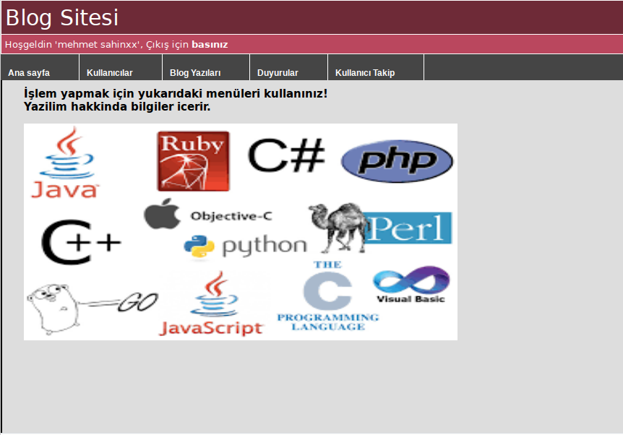
Figure 3. User Page

As a result, the admin on the site and the user can use the authorities defined by him without any problems. It is considered that all the required requirements for the assignment have been fulfilled.

Update: A small change was made at this stage of the project. 4 tables were thought to be unnecessary. In addition, a table named logUser was created for in-site input, output, operations, and so on. Thanks to this table, the transactions made by the users are not observed. Intrasite statistical data was received.

DIFFICULTIES AND PROJECT EVALUATION
During the implementation of the project, there were some problems normally quite normal. There are good aspects and bad aspects of running the project on the departmental server. It makes it easy to run directly on the partition server without needing another server on our own computer. In addition, it was an important convenience that the connections made in the department were seamless. But making a connection from a different network to the department server has caused some mistakes. Due to the connection from different network, continuous connection has been broken. This has also had a negative impact both on the loss of time and on the formation of the progeny. Another drawback is that the department server does not support some requirements. There have also been some drawbacks in this regard. In addition, delaying the resolution of these negativities also caused some disruptions. When viewed in general, it was a right decision to run it on the departmental server (with the missing ones).
It is also necessary to evaluate the project in general. It can be said that it is the process of developing a tidal project in its own right. It is thought to be experienced in important issues such as being a team, distribution of tasks, coping with problems, and so on. From the very beginning, it has been observed that the wrong tools were chosen, which caused unnecessary time loss.

